**Computational exercise: The electric field of many point charges revisited**

PH 220

**Objective:** Write a computer code that reads in the locations and charges of several point charges, calculates the potential at various points in space, then uses the gradient to calculate the components of the electric field at those points.

**Background:** Unlike the electric field, the electric potential is a scalar. Consequently, finding the electric field from an assemblage of point charges is more simple than finding the electric field directly.

The potential a distance  meters from a point charge of  Coulombs is given by

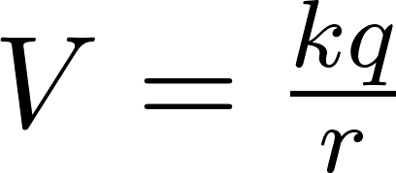

where 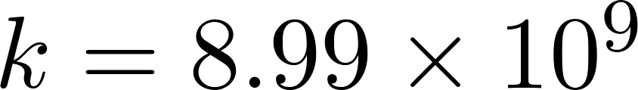 N m2/C2. Because the potential is a scalar, there is no direction associated with this number. If multiple source charges are present, one finds the net electric potential at any given point by finding the potentials for each of the source charges independently, and then simply adding them together.

Once the potential is known, one can calculate the components of the electric field using a gradient, i.e.

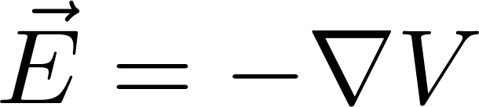

In order to calculate a gradient, we first must remember what the gradient is, i.e.

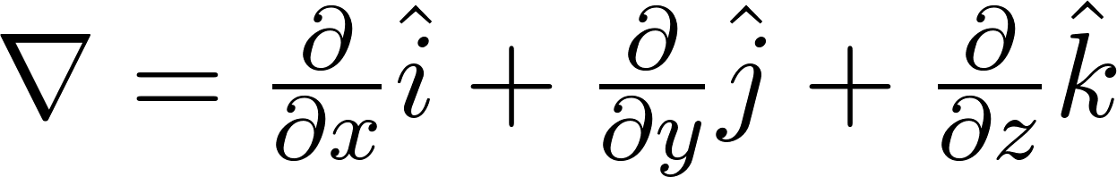

So, the electric field components will be

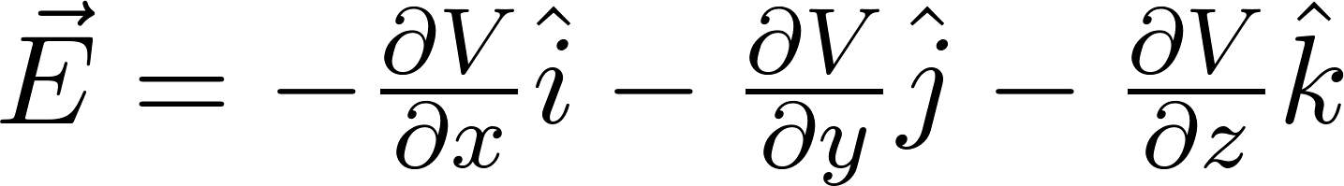

How does one find a derivative numerically? Simply recall how a derivative is defined:

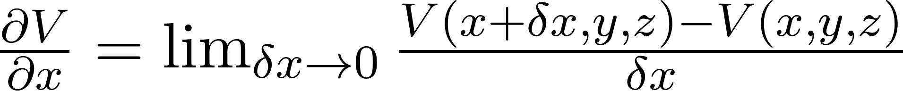

You simply choose a small 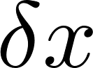 and evaluate this fraction. How small should  be? Generally speaking, you could make it about eight orders of magnitude smaller than , and not run into any trouble.

Since you will be evaluating the potential at several different places (four places for each test point), you will want to write a function that evaluates the potential. The function can simply return a floating point number (the potential), and should take as arguments the x, y, and z coordinates, as well as some arrays holding the charge and coordinates of each of your source charges. In C, the declaration of this function might look something like the following:

double potential(double x, double y, double z, int nsrc, double qsrc[], double xsrc[], double ysrc[], double zsrc[])

In other words, we pass to this function all of the information it will need to find the potential.

**Exercise requirements:** Write a computer code that does the following:

1. Reads a file specifying the number of source charges, the charge and the coordinates of each of the source charges, the number of points at which to find the potential and electric field, and the coordinates of those points. This input file will be formatted as follows. The first line of the input will consist of a single integer specifying how many source charges there are. The next lines, one for each source charge, gives the charge in nC, the x-coordinate in meters, the y-coordinate in meters, and the z-coordinate in meters. The source charge lines are followed by another single integer specifying how many points we are finding the electric field for. This is followed by a line for each of those points, giving the x-coordinate in meters, the y-coordinate in meters, and the z-coordinate in meters. The following is a sample input file:

|  |
| --- |
| 6  -3.450 1.323 -0.458 0.498  2.850 -1.685 2.254 -2.211  0.330 3.844 0.003 1.112  -5.440 -4.451 -3.239 -0.731  3.690 3.332 -3.854 -2.074  2.980 2.133 -2.298 3.287  4  0.000 0.000 0.000  1.000 0.000 2.000  0.000 1.000 0.000  0.000 1.000 -1.000 |

1. Calculates the electric potential at each of the requested points.
2. Calculates the electric field components at each of the requested points.
3. Writes out the coordinates of the requested points, in order, and the resulting electric potential and electric field components, formatted as follows:

|  |
| --- |
| 1: ( 0.000, 0.000, 0.000) V= -9.850 V E=< 10.725, -5.089, 5.157> N/C  2: ( 1.000, 0.000, 2.000) V= -5.953 V E=< 0.087, -1.098,-11.816> N/C  3: ( 0.000, 1.000, 0.000) V= -3.507 V E=< 4.461, -6.044, 3.271> N/C  4: ( 0.000, 1.000, -1.000) V= 0.892 V E=< 3.873, -4.898, 4.815> N/C |

**Validation:** You can verify whether your code is working correctly or not by feeding it the example input file above, and seeing whether it reproduces the example output.

**Grading rubric:** Your grade on this exercise, out of 50 points total, will be calculated based on the following criteria:

* Your code accurately finds the electric potential for a test input file that I provide. This test file will include five test coordinates. Each potential is worth two points. (10 points)
* Your code also accurately finds the electric field components for these test points, for a total of 15 electric field components. (15 points)
* Your code utilizes a separate function for calculating the electric potential. (5 points)
* Your code is well organized and “pretty”. (3 points)
* The output is formatted as required. (2 points)
* You have included all of the following comments in your code:
  + A header that describes what the code does and how to use it. (5 points)
  + A description of each of the variables in your code. (5 points)
  + Frequent descriptions of what your code is doing, including any numerical methods that you are employing. (5 points)